Task # 1:
i. Take an input from the user and store it in memory.
ii. Retrieve the stored value from memory using the LDA instruction.
iii. Display the loaded value as output.
Instructions:
Verify that the value remains the same after storage and retrieval.
Analyze the execution and document the results.

Solution:

LAD is the instruction that fetch the data from register to accumulator. It works reversibly from STA instruction.
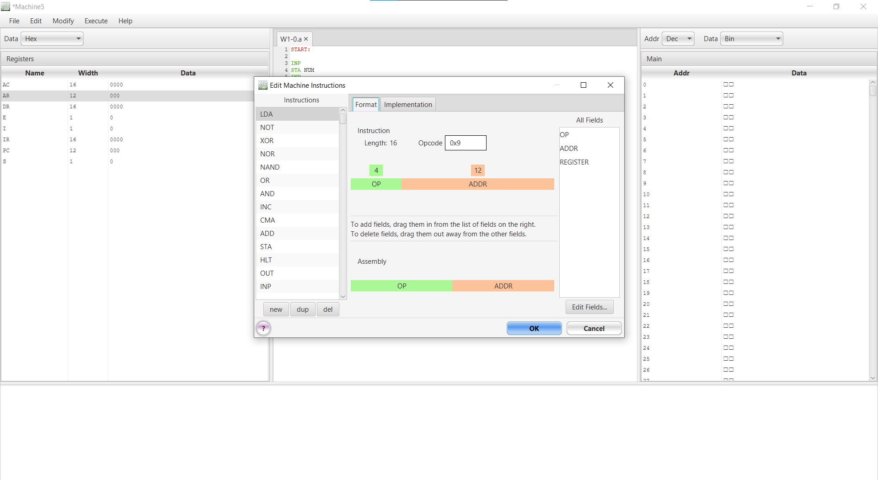

LDA instruction’s length is 16 bits, with a 4-bit Opcode (OP) and a 12-bit Address (ADDR). We set the instructions as to tell the CPU how to move data from memory to the Accumulator.
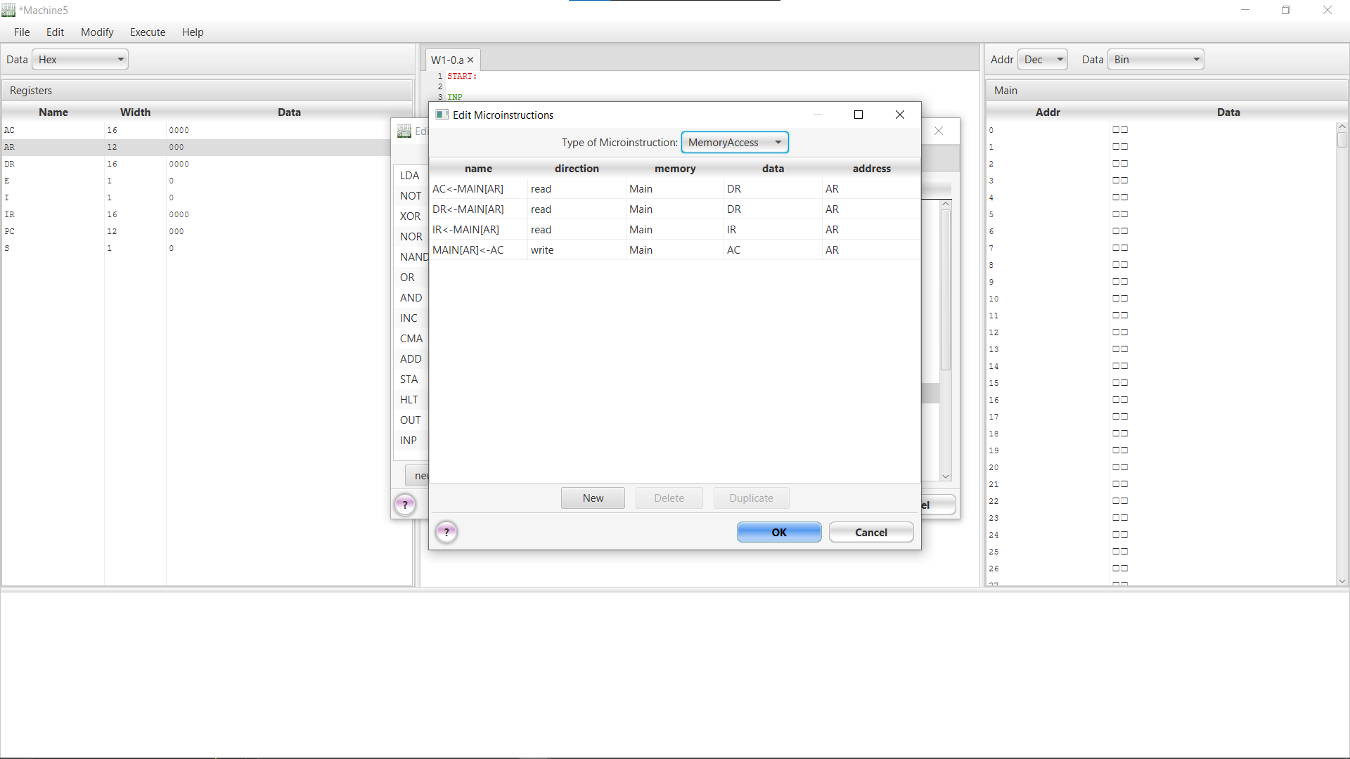We created a new microinstruction AC->MAIN[AR] which will take data hold in memory given by register and store it into accumulator register.
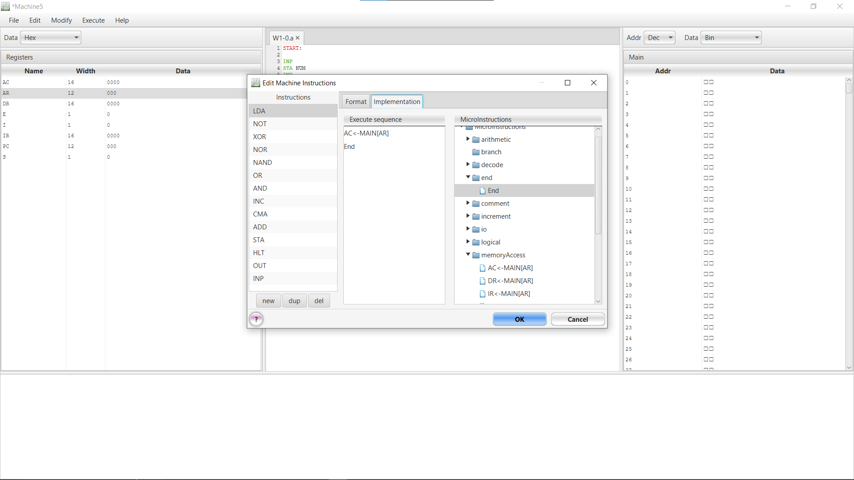
After setting Format, We will add commands through implementation. Select AC-> MAIN[AR] from Memory access microinstruction and end. LAD’s machine instruction is completed. Select OK.
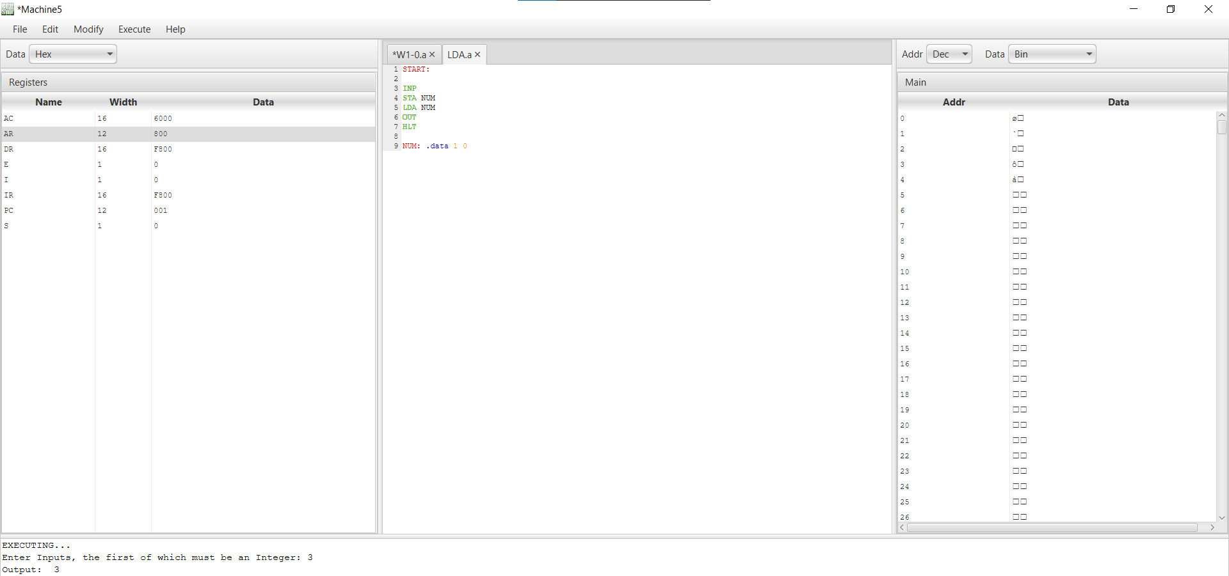

After setting instructions, write the code. According to code, we took a value from user. Then stored that value in Accumulator register to main memory using STA. Then we retrieve the data (number) from the main memory to the Accumulator by using LDA. After the completion of whole process, we concluded that the value remains the same after storage and retrieval.

